* **6115- MAHENDRA INSTITUTE OF ENGINEERING AND** **TECHNOLOGY**

**Traffic Mangement System**

**TEAM : PROJ_223283_TEAM_2**

**Team members:**

* **RAHUL R**
* **RAM KUMAR R**
* **SANJAY M**
* **VIGNESHWARN S**
* **VIJAY AKASH S**
* **PRAVEEN KUMAR R**

**Role of IOT in Traffic Management System:**

The role of IoT in traffic management is transformative, introducing a paradigm shift in how cities optimize and regulate their transportation systems.

By embedding sensors and connectivity into vehicles, roads, traffic lights, and other infrastructure, IoT enables the collection of real-time data on traffic patterns, congestion, vehicle movements, and more.

This data is then processed and analyzed to make informed decisions, dynamically adjusting traffic signals, rerouting vehicles, and improving overall traffic flow.

This intelligent management level enhances road safety, reduces congestion, lowers emissions, and creates more efficient and sustainable urban mobility systems.

**EXISTING SYSTEM:**

In general, our research cover the literature review from various sources based on traffic control and vehicle tracking.

This method examine the adaptive fine tuning algorithm to create a set of design parameters of two well defined mutually interacting modules of the trafficresponsive urban control(TUC)strategy for the large scale urban road network of the city of China, Greece.

Computer simulation outcome are given, demonstrating that the network performance in terms of the daily mean speed, which is attained by the proposed adaptive optimization methodology, is significantly better than the original TUC System in the case in which the-aforementioned design parameters are mutually fine-tuned to virtual perfection by the system operation [1].The system will develop the trafficlight configuration, which will be able to determine three street case (empty street case, normal street case and crowded street case) by using small associative memory.

The experiments presented provides promising results when the proposed approach was applied by using a program to monitor intersection in penesa island in Malaysia. The program could determine the street cases with different atmospheric conditions depending on the stream of images, which are extracted from the street video cameras[2]. To handle congestion in urban traffic flow through next generation artificial intelligence techniques is an important research area.

Various intelligent and approach have been developed using sot computing techniques to tackle with this problem. This paper is an attempt towards revisiting such approach in developing modern traffic control systems[3].

This study focus on the utilization of RFID as a way of traffic flow detection, which transmits collection information connected to traffic flow straight to a control system using an RS 232 interface, At the same time, the sensor analyzes and Judges the information using an extension algorithm designed to accomplish the subjective of controlling the flow of traffic.

In add-on, the traffic flow condition is also transmitted to a remote monitoring control system through ZigBee wireless network communication technology.

The traffic flow control system developed in this study can execute remote transmission and reduce traffic accidents. And it can also effectively control traffic flow while reducing traffic delay time andmaintain the smooth flow of traffic [4].

This system includes RFID technology and Lab view software. The RFID reader reads the Identification number from the related ambulance RFID tag and then it is sends the data to micro controller LPC 1768H, which is programmed, with the help of embedded C instructions. Those microcontroller is capable of communicating with input and output modules.

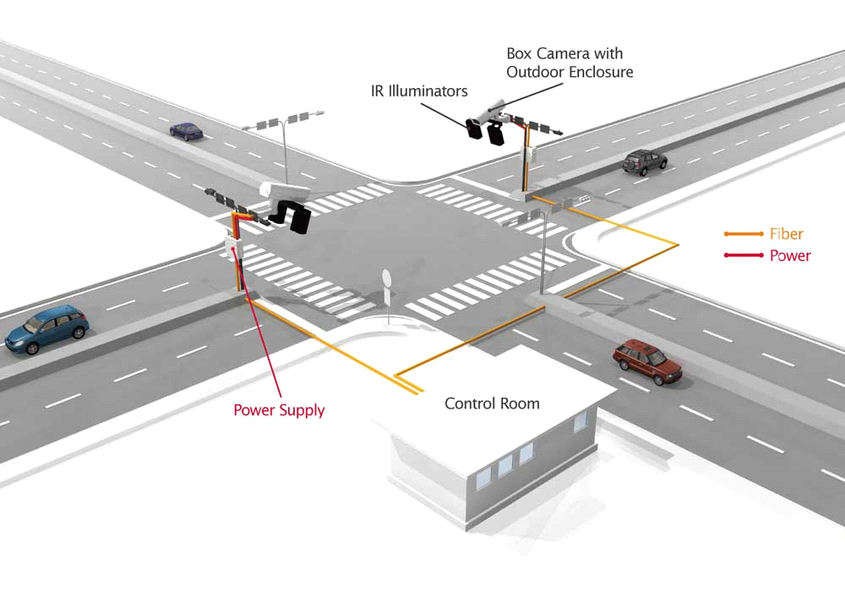

**Diagrammatic Representation**

**PROPOSED SYSTEM :**

The solution we provide for Traffic management by reading the RFID tag of each car by a RFID reader at traffic junctions for real time traffic density calculation. It also concentration on changing the traffic lights according to vehicle tightness on the road, thereby intent at reducing the traffic congestion on roads.

In turn, it'll reduce fuel consumption and waiting time. In case of emergency vehicle like ambulance Radio Frequency module will be used so that red traffic light signals will be turned to green in order to provide a clear way for the emergency vehicles.

It will also provide significant data which can help in future road planning and analysis. It is also used to detect or track stolen vehicle. It also alerts the owner of thevehicle to top up the credit which is used in toll booth.

In further time period multiple traffic lights are often synchronized with one another with an goal of even fewer traffic jam and free flow of traffic. The vehicles are detected by the system through RFID tag which is read by the RFID reader. RFID reader is present in some meters away from the signal and another RFID reader is placed alongside the traffic light. It will capture the number of vehicles in that particular lane.

RFID is a better technique to control the state change of the traffic light since RFID is mandatory for all the vehicles in India. It shows that it can decrease the traffic jam and avoids the nonce wasted by a green light on an empty road. It is also more certain in estimating vehicle existence.

**OVERVIEW OF PROPOSED SYSTEM:**

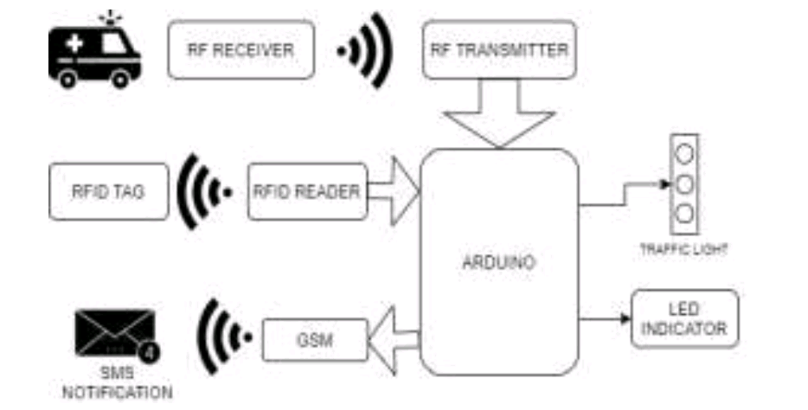

Black diagram of proposed system

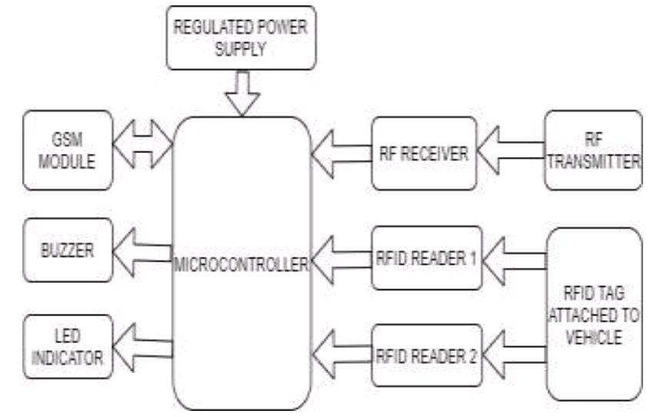

A signal junction with RFID reader.

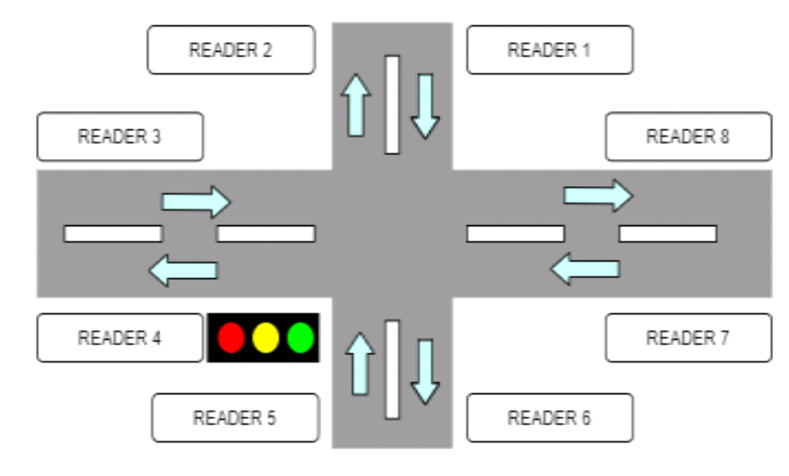

**ADVANTAGE OF PROPOSED SYSTEM** :

* Reduces traffic jams at the signals and on the streets
* Real-time vehicular movement monitoring
* A large chunk of vehicles can transit the signals efficiently
* Tracking lost vehicles using RFID
* Efficient and accurate traffic monitoring
* Instant traffic clearance for emergency vehicle

- THANK YOU -